**Neural Networks and Deep Learning – ICP 7**

**GitHub Link:** https://github.com/shanmukha1610/NNDL_ASS7

**VideoLink :**https://drive.google.com/file/d/1D6si7ckcmF_k9uoZVT63YtdZyE91z4qA/view?usp=drive_link

**Name: Pasumarthi Shanmukha Laxmi**

**Student ID: 700756736**

**Deep Learning Image Classification with CNN**

Use Case Description:

Image Classification with CNN

1. Training the model

2. Evaluating the model

This code creates a simple Convolutional Neural Network (CNN) model for the CIFAR-10 dataset, which is a collection of 60,000 32x32 color images in 10 classes. The code first loads the dataset and preprocessed the data by normalizing it to the range of 0.0 to 1.0 and one-hot encoding the output labels. The model includes a convolutional input layer, dropout layers, convolutional layers, max-pooling layers, and fully connected layers. The model is compiled with stochastic gradient descent (SGD) optimizer and categorical cross-entropy loss function. The model is then trained on the dataset for 25 epochs with a batch size of 32, and the accuracy of the model is printed.

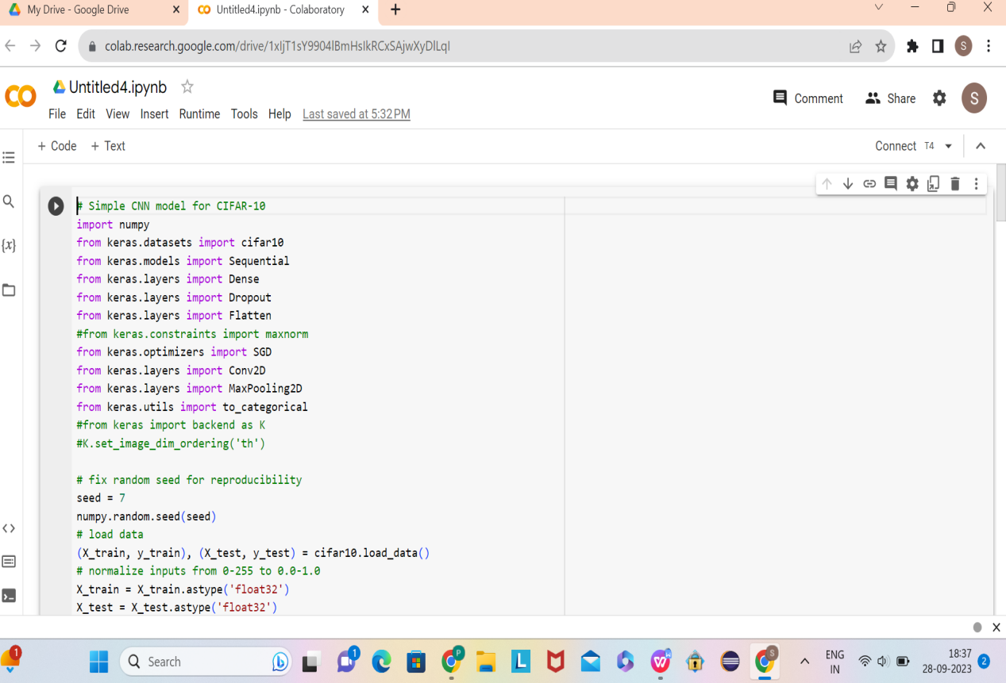

(X_train, y_train) represents the training set, while (X_test, y_test) represents the test set. The training set is used to train the model, while the test set is used to evaluate the performance of the model on unseen data. The code given by you upon correction and execution gives the accuracy as 71.08% as shown below:

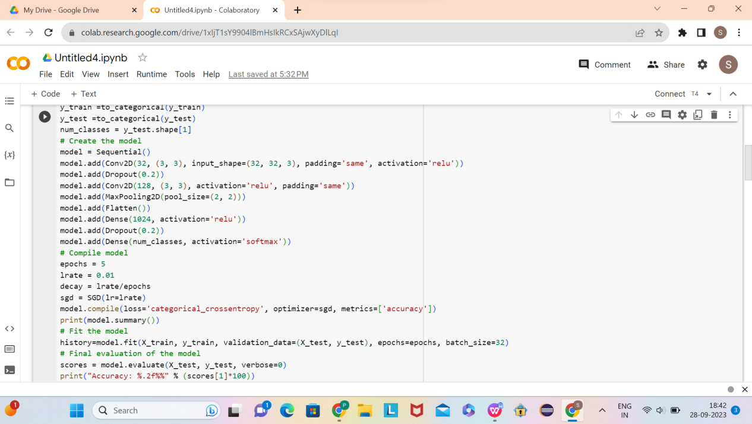

1. **Follow the instruction below and then report how the performance changed. (Apply all at once).**

To the above code I have made changes according to the question and added the following and applied them all at once as shown below.

Conv2D layer with 32 feature maps, kernel size of 3x3, padding='same', and activation function='relu'. The input_shape is (32, 32, 3) which corresponds to the dimensions of the input image (height, width, depth). This layer applies 32 filters to the input image and each filter generates a feature map.

Dropout layer with a rate of 0.2. This layer randomly sets 20% of the input units to 0 at each update during training, which helps to prevent over-fitting.

Conv2D layer with 32 feature maps, kernel size of 3x3, padding='same', and activation function='relu'. This layer applies another set of 32 filters to the input image, generating a new set of feature maps.

MaxPooling2D layer with pool_size of 2x2. This layer down-samples the feature maps by taking the maximum value within each 2x2 block.

Conv2D layer with 64 feature maps, kernel size of 3x3, padding='same', and activation function='relu'. This layer applies 64 filters to the input image and generates 64 feature maps.

Dropout layer with a rate of 0.2.

Conv2D layer with 64 feature maps, kernel size of 3x3, padding='same', and activation function='relu'. This layer applies another set of 64 filters to the input image, generating a new set of feature maps.

MaxPooling2D layer with pool_size of 2x2.

Conv2D layer with 128 feature maps, kernel size of 3x3, padding='same', and activation function='relu'. This layer applies 128 filters to the input image and generates 128 feature maps.

Dropout layer with a rate of 0.2.

Conv2D layer with 128 feature maps, kernel size of 3x3, padding='same', and activation function='relu'. This layer applies another set of 128 filters to the input image, generating a new set of feature maps.

MaxPooling2D layer with pool_size of 2x2.

Flatten layer. This layer flattens the output of the previous layer, creating a 1D vector that can be used as input to a fully connected layer.

Dropout layer with a rate of 0.2.

Dense layer with 1024 units and activation function='relu'. This layer is fully connected and applies a rectified linear activation function to its inputs.

Dropout layer with a rate of 0.2.

Dense layer with 512 units and activation function='relu'.

Dropout layer with a rate of 0.2.

Dense layer with num_classes=10 units and activation function='softmax'. This layer is the output layer and applies the softmax activation function to produce the output probabilities for each class.

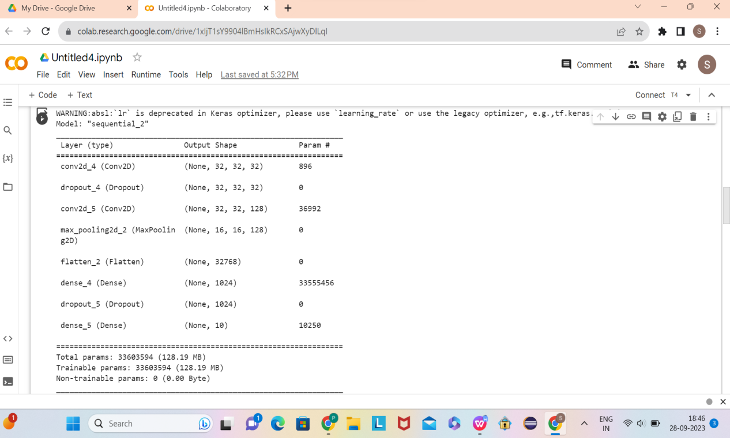

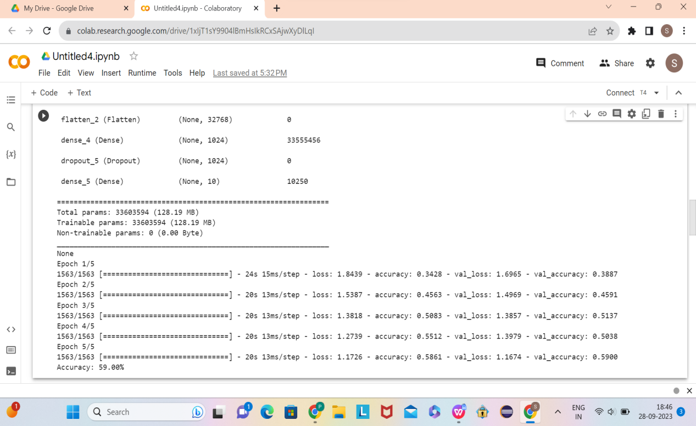

1. **Predict the first 4 images of the test data using the above model. Then, compare with the actual label for those 4 images to check whether or not the model has predicted correctly.**

I have now written the following code which is creating a prediction for the first four images in the test set using a trained neural network model.

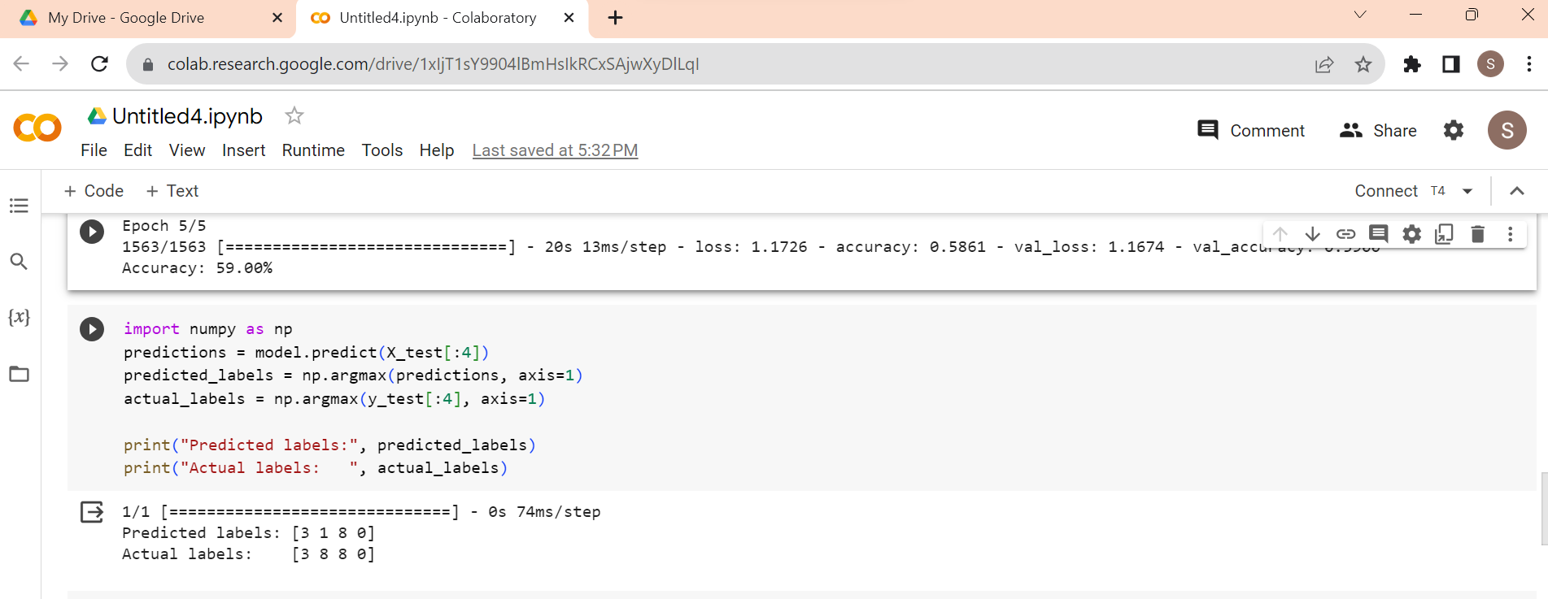

**3. Visualize Loss and Accuracy using the history object**

I am now plotting the accuracy and loss of a trained neural network model during training and validation.

The history object returned by the fit() method contains information about the training process, including the accuracy and loss at each epoch for both training and validation datasets.

The code plots the accuracy and loss for both training and validation datasets over the course of the training process using plt.plot().

In summary, this code creates a visualization that allows us to see how the accuracy and loss of our neural network model changeover the course of training and validation.

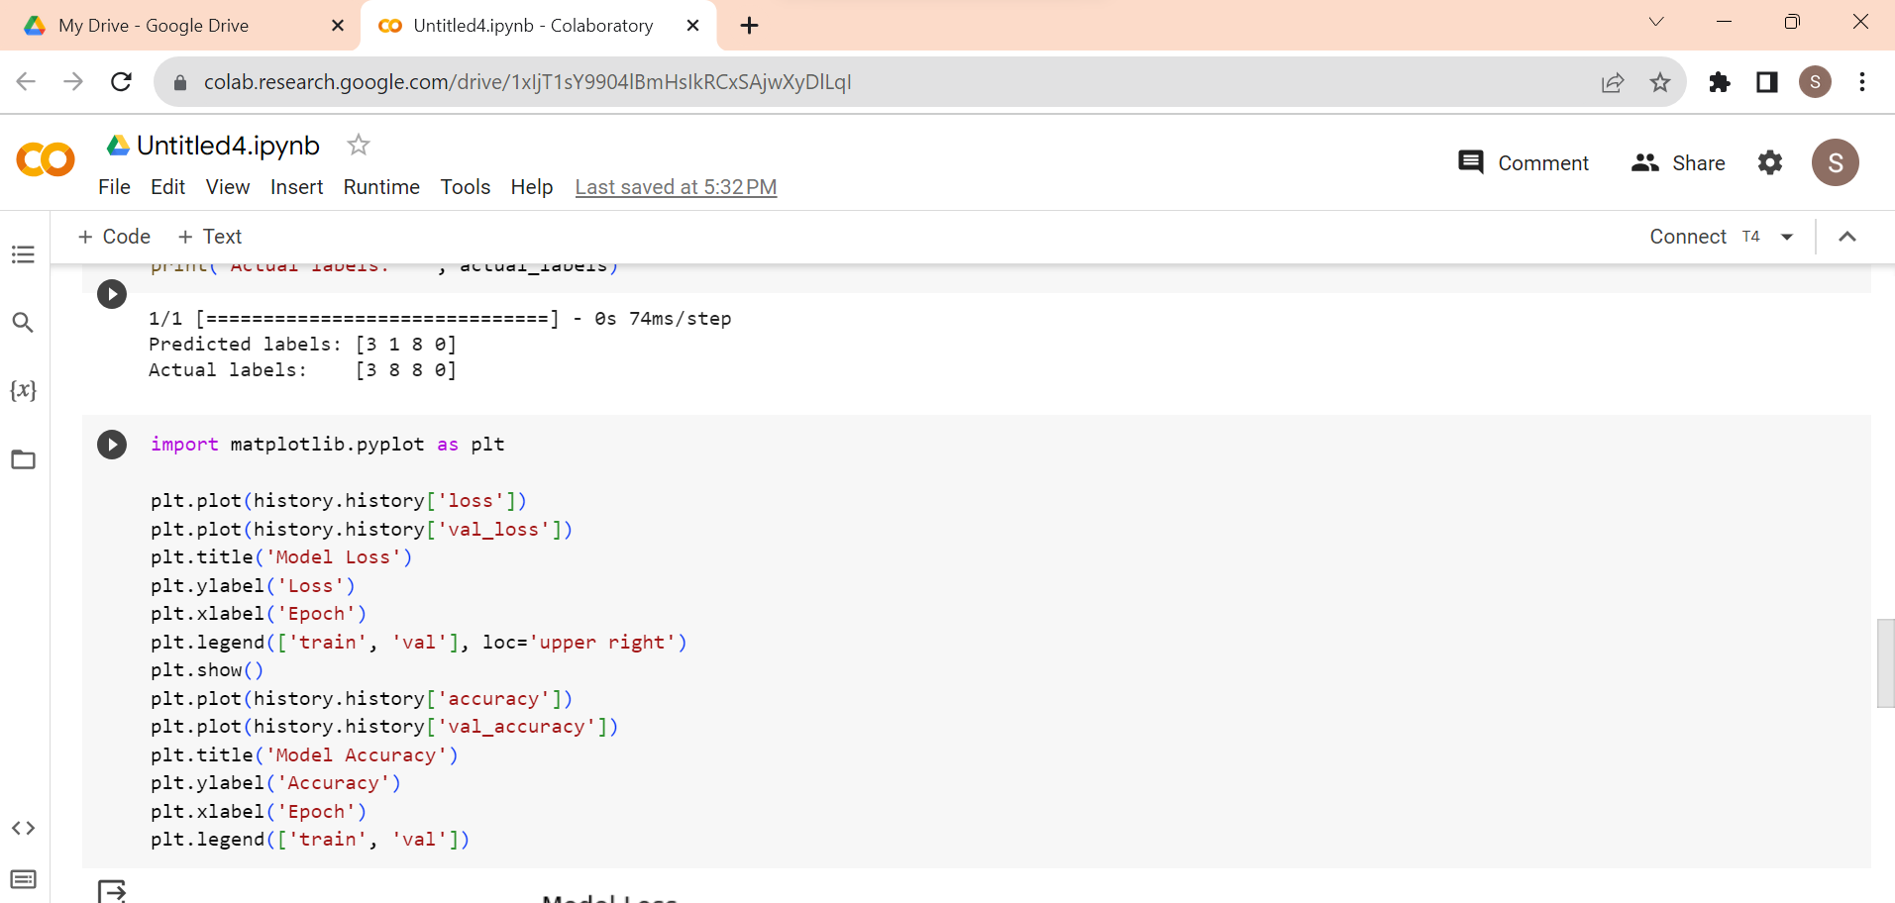

Upon executing the above code, the visualization of accuracy and loss is displayed as shown below:

